Project Report

Project Title: Image Recognition for Wildlife Conservation

This project has been completed under the guidance of Nirmaan Organization, an NGO, which is sponsored by Microsoft. Nirmaan provides students, free courses on AI, DA, ITES, AWS, WebApps etc. It has its branches at the multiple locations in India. It aims at upskilling the students and helps them with job opportunities. It is completely free and aims at only providing employment opportunities.

Faculty Name | Date | Version
Sonali Kohli | 25-09-2024 | 1.0

- Abstract: In an era where biodiversity is under unprecedented threat, wildlife conservation efforts require innovative technological solutions to monitor species and ecosystems effectively. This project aims to develop a computer vision model using YOLO (You Only Look Once) object detection to identify and classify wildlife species in images. The model will assist conservationists and ecologists in tracking species distribution, population density, and behavioral patterns, facilitating more accurate biodiversity monitoring. The model is trained using an open-source dataset from Kaggle, which contains diverse wildlife images. The integration of artificial intelligence (AI) into conservation will enhance data collection efficiency, minimize human intervention, and provide scalable solutions to monitor vast wildlife areas, ultimately aiding in wildlife protection and conservation efforts.

Table of Contents Page Nos

Introduction 4
Objective 5
Methodology 6-8
Results 9-10
Challenges/Future Scopes 10-11
References 11

Introduction:
Wildlife conservation is crucial to preserving Earth's biodiversity, yet monitoring wildlife populations and their habitats presents significant challenges. Traditional methods of wildlife monitoring, such as manual field surveys and camera trapping, are often labor-intensive, time-consuming, and subject to human error.
This project focuses on developing an AI-powered image recognition system using YOLO object detection models. YOLO models have revolutionized object detection with their real-time detection capabilities and high accuracy. By leveraging pre-trained YOLO models and training them on a wildlife dataset from Kaggle, this project aims to create a system that can automatically detect, identify, and classify wildlife species from camera trap images. This approach has immense potential in ecological research, biodiversity assessment, and endangered species protection.

- Data Collection: JPG 5000 images dataset
- FilePath: afhq/train/wild or cat or dog
afhq/Val/wild or cat or dog

Objective

Problem
- To record the details of dangerous wild species in live.
- To roam whole time under forest region and gather information of conservation.
Objective of this project
- Wildlife Species Detection and Classification: To build a computer vision model that accurately detects and classifies wildlife species captured in images.
- Real-time Object Detection: Implement a YOLO-based object detection model capable of identifying animals in camera trap footage and images with minimal latency. Enhance biodiversity monitoring efforts, helping protect endangered species and maintain ecosystem balance.
- Biodiversity Monitoring Scalability and Deployment: : Provide ecologists and conservationists with a tool that can automatically track and monitor wildlife, facilitating more effective conservation strategies.Demonstrate the scalability of the model by running it on Google Colab, making it accessible for environmental researchers with limited computational resources
Constraints
Perform search on large datasets
Methodology

- Algorithm used – YOLO(you only look once), CNN and NMS architecture under YOLO

- Libraries used – pandas,
- NumPy
- Sklearn
- ultralytics
- torch (PyTorch)
- opencv-python (cv2)
- Pillow (PIL.Image)
- import os
- import matplotlib.pyplot as plt

- Methodologies used – Real time object detection> species images> naming and classification.
This above work is done through 7 successive methods:
1. Dataset Collection
- The dataset for this project is sourced from Kaggle, specifically the "Animal Faces" dataset, which contains labeled images of different species.The dataset will be split into training, validation, and test sets to evaluate the model's performance.

2. Preprocessing
Image Augmentation is To improve the model's robustness, techniques such as flipping, rotation, scaling, and brightness adjustment will be applied to augment the dataset.
Label Formatting: Convert dataset annotations into the YOLO format, ensuring proper bounding box coordinates and class labels are prepared for model training.
3. YOLO Model Selection
YOLOv8: The project will utilize the YOLOv8 model due to its speed and accuracy in real-time object detection. This model will be loaded using the ultralytics library in Python.The pre-trained YOLO model will be fine-tuned on the wildlife dataset to detect species such as cats, dogs, and various wild animals.
4. Model Training
Model transfer Learning Instead of training the YOLO model from scratch, transfer learning will be applied. This method leverages a pre-trained model (trained on large datasets like COCO) and fine-tunes it on the wildlife dataset.
5. Evaluation
The trained model will be evaluated using standard object detection metrics.The model’s ability to detect and count specific species (e.g., cats, dogs, wild animals) will be tested on a separate validation dataset.

6. Counting and Classification
Post-processing the model’s predictions to classify detected animals into categories such as cats, dogs, and wild animals.A counting mechanism will be implemented to track the number of each species in the dataset or live images.
7. Deployment
The model will be deployed and tested using Google Colab, ensuring ease of use and access for conservationists and researchers without high computational resources.Integration with camera trap systems could be explored as a future step.

Results
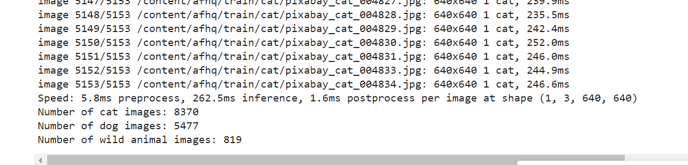
Counting and classification
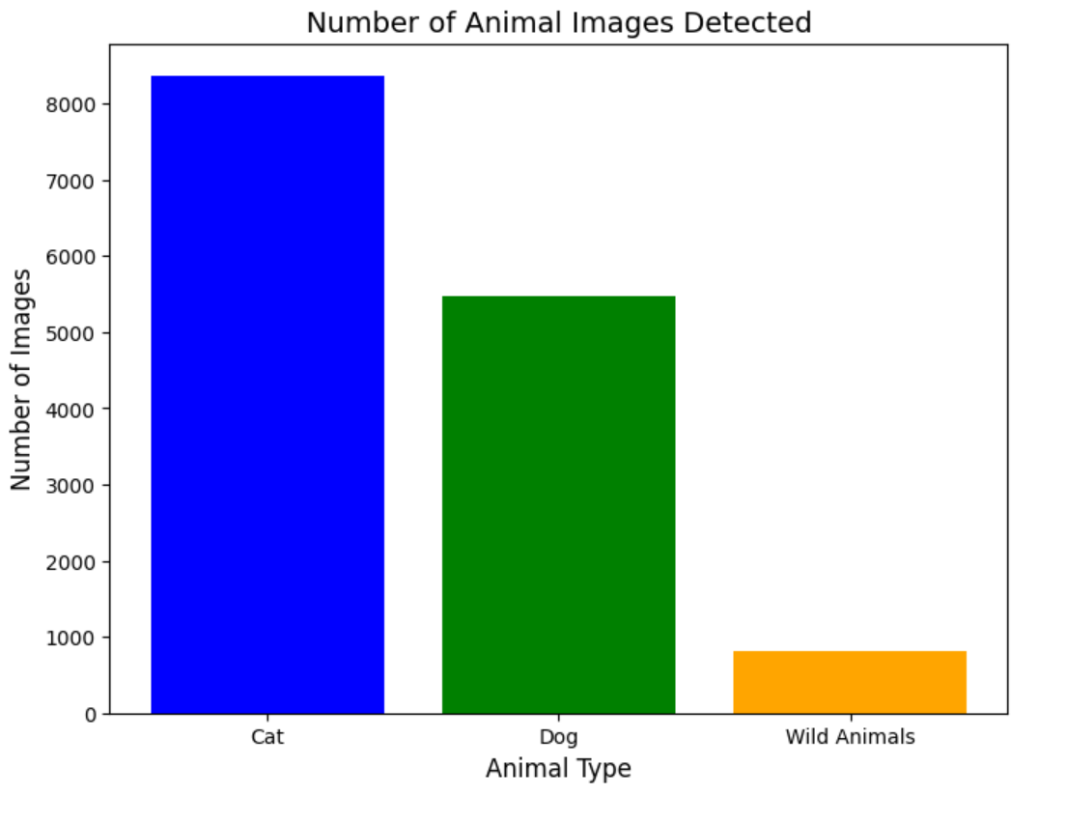
Bar graph plot
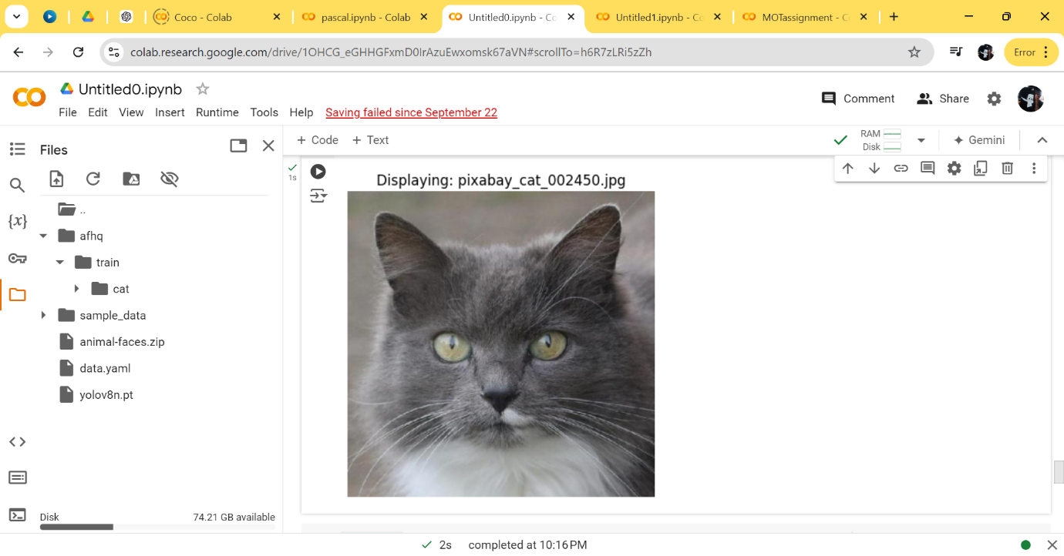

Displaying Output

Challenges/Future Scopes
The future of AI-based wildlife monitoring holds great potential for conservation efforts. As this project lays the foundation for wildlife species detection using YOLO, several directions for future enhancement and application are possible:
Extended Species Detection
Real-time Monitoring Systems
Behavioral Analysis
Collaboration with Conservation Agencies
Advanced Models
By integrating AI and computer vision into wildlife conservation, this project aims to make a significant impact on biodiversity monitoring and protection efforts. Through continuous advancements, this technology has the potential to revolutionize the way we observe and preserve wildlife across the globe

References

